**Engineering Service Learning**

**at UC Merced**

**Project Report**

Team: UAV TEAM

Project: Leaf Scorching Detection Cooperative Extension

Date: Fall 2015

1 Design Status Summary 3

2 Project Charter 4

2.1 Description of the Community Partner 4

2.2 Stakeholders 4

2.3 Project Objectives 4

2.4 Outcomes/Deliverables 4

2.5 Overall Project Timeline 4

3 Overall Project Design 5

3.1 Phase One: Project Identification Fall 2015 5

3.2 Phase Two: Specification Development Fall 2015 6

3.3 Phase Three: Conceptual Design Fall 2015 7

3.4 Phase Four: Detailed Design Fall 2015 8

3.5 Phase Five: Delivery Fall 2015 9

3.6 Phase Six: Service / Maintenance Fall 2015 10

4 Semester Documentation Fall 2015 11

4.1 Team Member 11

4.2 Current Status and Location on Overall Project Timeline 11

4.2.1 Goals for the Semester 11

4.2.2 Semester Timeline 11

4.2.3 Semester Budget 11

4.2.4 Summary of Semester Progress / Comparison of Actual Semester Timeline to Proposed Semester Timeline 11

4.3 Transition Report 11

4.3.1 Draft Timeline for Spring 2015 and Relationship to Overall Project Timeline 11

5 Past Semester Archive 12

5.1 Past Semester 1 12

5.1.1 Past Team Members 12

5.1.2 Past Timeline 12

5.2 Past Semester 2 12

5.2.1 Past team Members 12

5.2.2 Past Timeline 12

# Design Status Summary

|  |  |
| --- | --- |
| **Phase 1: Project Identification** | **Status:** Complete |
| ***Gate 1: Continue if have identified appropriate Engineering Service Learning project that meets a compelling need for the project partner.*** | |
| Date of Advisor approval: | Spring 2014 |
|  |  |
| **Phase 2: Specification Development** | **Status:** Complete |
| ***Gate 2: Continue if project partner and advisor agree that you have identified the “right” need, specification document is completed and no existing commercial products meet design specifications.*** | |
| Date of Advisor approval: | Fall 2014 |
|  |  |
| **Phase 3: Conceptual Design** | **Status:** Complete |
| ***Gate 3: Continue if project partner and advisor agree that solution space has been appropriately explored and the best solution has been chosen.*** | |
| Date of Advisor approval: |  |
|  |  |
| **Phase 4: Detailed Design** | Status: In progress |
| ***Gate 4: Continue if can demonstrate feasibility of solution (is there a working prototype?). Project Partner and advisor approval required.*** | |
| Date of Advisor approval: |  |
|  |  |
| **Phase 5: Delivery** | **Status:** |
| ***Gate 5: Continue if Project Partner, Advisor and Engineering Service Learning Admin agree that project is ready for delivery!*** | |
| Date of Advisor approval: |  |
|  |  |
| **Phase 6: Service / Maintenance** | **Status:** |
| ***Gate 6: Project Partner and Advisor approve continued fielding of project. If not, retire or redesign.*** | |
| Date of Advisor approval: |  |

# Project Charter

**Introduction**

Precision agriculture is an experimental field of study that uses modern technology to precisely observe, measure, and respond to problematic crop conditions.  The goal of precision agriculture is to preserve valuable resources while optimizing output, an issue that is particularly important amidst California’s ongoing drought.  Precision techniques most commonly include the analysis and manipulation of aerial photography.  By measuring the energy emission of crops through images taken in visible, near-infrared, or infrared wavelengths, farmers are able to observe which areas of their crops are under stress from variety of factors that include water allocation, pest control, temperature, and disease.

An issue of particular importance to California’s vineyards is Pierce’s disease, a bacterial infection spread by an insect called the glassy-winged sharpshooter that is capable of killing a vine within two years by blocking the movement of water.  Without intervention Pierce’s disease threatens to decimate California’s $3 billion wine grape industry, just as it has in the past in the 1880s, in the 1930s, and in the 1940s.  According to an article published in California Agriculture in 2014, Pierce’s disease has cost an estimated $104.4 million per year in loss of production, vine replacement, and disease research since the 1990s (Tumber, Alston, and Fuller).

The fall 2015 Semester Unmanned Aerial Vehicle (hereafter referred to as “UAV”) team of Engineering Service Learning at UC Merced is working to design and implement a UAV system that will provide local, small-scale farmers with an efficient method of disease detection and crop management through precision techniques.  By designing an autonomous aerial device and a post-flight image analysis program from inexpensive parts and materials, the UAV team hopes to reduce the cost to the farmer who wishes to employ precision techniques to detect and stop the spread of disease in perennial crops.  The unmanned vehicle in question will monitor crops and extract meaningful data with minimal input from the consumer, allowing farmers to optimize crop yield and preserve resources in a timely and efficient manner.

The formal community partner for the UAV team is the University of California Cooperative Extension (UCCE). The UCCE consists of agricultural subdivisions stationed throughout California’s agricultural basin that employ experimental techniques to solve local issues.  The main goal of the UAV team as dictated by UCCE is to provide an easier, faster, and more efficient way for farmers to detect diseased crops before widespread crop destruction.  The team’s point of contact within UCCE is Larry Burrow, an agricultural field technician, who provides the team with feedback and expertise about the particular needs of the farmers who wish to use precision techniques in crop management.

By the end of the project, the unmanned vehicle will be capable of autonomous flight and photography of the area of interest. Through subsequent image analysis, the system will be able to detect leaf scorching in vineyards caused by Pierce’s Disease. The development of this system will allow local farmers to detect possible threats before they become catastrophic to their entire crop. The finished product should be a cost-effective alternative to existing methods, not only in the early detection of loss to yield but also in the optimization of labor resources in the detection of diseased crops.

[Location of signed Project Charter:](https://ucmerced.app.box.com/files/0/f/2825674635/1/f_24007821115)

# Overall Project Design

## Phase One: Project Identification (Spring 2014)

|  |  |  |
| --- | --- | --- |
| **Phase 1: Project Identification** | **Status:** Completed | **Evidence can be found:**  [**Project Identification folder Spring 2014**](https://ucmerced.app.box.com/files/0/f/5665418873/Project_Identification) |
| Goal is to identify a specific, compelling need to be addressed | | |
| Conduct needs assessment (if need not already defined) | Completed | [Needs Assessment Folder Spring 2014](https://ucmerced.app.box.com/files/0/f/5665698149/Needs_Assessment) |
| Identify stakeholders (customer, users, person maintaining project, etc.) | Completed | [Client and Stakeholders Folder Spring 2014](https://ucmerced.app.box.com/files/0/f/5665945413/Client_and_Stakeholders) |
| Understand the Social Context | Completed | [Social Context Folder Spring 2014](https://ucmerced.app.box.com/files/0/f/5665837553/Social_Context) |
| Define basic stakeholder requirements (objectives or goals of projects and constraints) | Completed | [Stakeholder Requirements Spring 2014](https://ucmerced.app.box.com/files/0/f/2501186143/Public_or_Professor_Feedback) |
| Determine time constraints of the project | Completed | [Time Constraints Folder Spring 2014](https://ucmerced.app.box.com/files/0/f/5666033429/Time_Constraints) |
| Gate 1: Continue if have identified appropriate Engineering Service Learning project that meets a compelling need for the project partner [This includes a Project Charter] | | |
| Advisor approval: | Yes / No | Date: May 2014 |

For the Spring Semester 2014 UAV Team, their main goal was to not only identify the project, but to assess their primary goals and constraints.  After meeting with Silkwood Winery, it was clear to the team that there were many goals that would need to be addressed, from getting the UAV in the air to controlling the flight of the drone with a payload attachment.  The team was able to successfully complete and identify multiple milestones they reached by the semester's end, as well as identifying the next steps required for the fall 2014 UAV team.

By the end of the spring 2014 semester, the project scope had been determined, and the overall project was approved by their community partner.  The team identified potentially useful software, and the general design specifications of the UAV and its payload.  Lastly, the team purchased and received their drone and additional payload parts.

Lastly, the team identified the next steps in the project for the fall 2014 team.  The first of these steps was to assemble the UAV and begin test flights.  In order to achieve autonomous analysis, the next team was also directed to automate the payload camera using an Arduino microcontroller to take a series of aerial photographs.  The team was then suggested to develop, ground proof, and refine algorithms for analysis, while creating a user friendly software package for ease of use.

## Phase Two: Specification Development (Spring 2014)

|  |  |  |
| --- | --- | --- |
| **Phase 2: Specification Development** | **Status:** Completed | **Evidence can be found:**  [**UAV_Team_Fall_2014**](https://ucmerced.app.box.com/files/0/f/2501097209/Fall_2014) |
| Goal is to understand “what” is needed by understanding the context, stakeholders, requirements of the project, and why current solutions don’t meet need, and to develop measurable criteria in which design concepts can be evaluated. | | |
| Understand and describe context (current situation and environment) | Completed | [Environmental Factors and Current Situation](https://ucmerced.app.box.com/files/0/f/5685942021/Environmental_Factors) |
| Create stakeholder profiles | Completed | [Stakeholder Profile Fall 2014](https://ucmerced.app.box.com/files/0/f/5684676993/Stakeholder_Profile) |
| Create mock-ups and simple prototypes: quick, low-cost, multiple cycles incorporating feedback | Completed | [3D Models Fall 2014](https://ucmerced.app.box.com/files/0/f/2562742199/3d_models) |
| Develop a task analysis and define how users will interact with project (user scenarios) | Completed | [Fall 2014 Task and User Interaction](https://ucmerced.app.box.com/files/0/f/5685036009/Tasks_and_User_Interaction) |
| Identify other solutions to similar needs and identify benchmark products (prior art) | Completed | [Similar Solutions](https://ucmerced.app.box.com/files/0/f/5685889329/Similar_Solutions) |
| Define customer requirements in more detail; get project partner approval | Completed | [Stakeholder Profile Fall 2014](https://ucmerced.app.box.com/files/0/f/5684676993/Stakeholder_Profile) |
| Develop specifications document | Completed | [Specifications Fall 2014](https://ucmerced.app.box.com/files/0/f/5685172293/Specifications_Fall_2014) |
| Establish evaluation criteria | Completed | [Evaluation Criteria Fall 2014](https://ucmerced.app.box.com/files/0/f/5685207609/Evaluation_Criteria) |
| Gate 2: Continue if project partner and advisor agree that you have identified the “right” need, specification document is completed and no existing commercial products meet design specifications. [This includes their agreeing that you have captured and documented the critical requirements and specifications for this project] | | |
| Advisor approval: |  |  |

The main goal of the Fall Semester 2014 UAV Team was to identify the context and detailed needs of the stakeholders. Also, the team set out to determine possible solutions to the problem addressed in the previous semester.  At the end of the semester the team was able to determine that the Iris+ is the correct platform for the system. They found that it would be difficult to replace parts if the UAV was custom. They also found possible programing solutions to aid in image stitching and analyzing. The team has prepared all of the proper specifications to help the team move on to the conceptual design phase during the spring 2015 Semester.

## Phase Three: Conceptual Design (Spring 2015)

|  |  |  |
| --- | --- | --- |
| **Phase 3: Conceptual Design** | **Status:** Complete | **Evidence can be found:** |
| Goal is to expand the design space to include as many solutions as possible. Evaluate different approaches and selecting “best” one to move forward. Exploring “how”. | | |
| Complete functional decomposition |  |  |
| Brainstorm several possible solutions | Complete | [Proposed Concepts/Solutions Spring 2015](https://ucmerced.box.com/s/pjc41j0o3tiro1eukcchvjdxmhlm7bgl) |
| Prior Artifacts Research | Complete | [Research Spring 2015](https://ucmerced.box.com/s/xt06l64nd5dsqzxjoyhj617d99pjc0bg) |
| Create prototypes of multiple concepts, get feedback from users, refine specifications | Complete | [Mounting Prototypes/Concepts Spring 2015](https://ucmerced.box.com/s/qq9b4vu5zdaovwxmuppum94lkkykz33e) |
| Evaluate feasibility of potential solutions (proof-of-concept prototypes) | Complete | [Solution Feasibility Spring 2015](https://ucmerced.box.com/s/vxqvszolg22gfhm3w8yvx3bz1orz2e9r) |
| Choose "best" solution | Complete | ['Best' Solution Spring 2015](https://ucmerced.box.com/s/arg8xv1ixr68154wrldnkdvxukot9fzb) |
| Gate 3: Continue if project partner and advisor agree that solution space has been appropriately explored and the best solution has been chosen. | | |
| Advisor approval: |  | Date: |

In the spring 2015 semester, the UAV team was in the conceptual design phase.  The main goals of this phase are to brainstorm how to approach and solve the problem that is posed, then evaluate these proposed solutions to discern which solution would serve as the best route for the team to follow.  Reflecting this, a large portion of the semester was dedicated to coming up with ideas, potential solutions, and figuring out how these could be tested.

One example of which was the creating of the camera case.  The problem posed in this instance was to safely and securely attach the camera to the drone.  Once the camera case was printed and ensured to hold the camera, the next tasks were to attach it to the camera and ensure that the position and vibration of the camera were suitable.  In the examination of this it was discovered that with the current setup the vibration was too extreme for the images to come out clear which would result in poor analysis.  The next issue is that a quadcopter operates by tilting to move.  With a rigid camera support system, the camera would be turned at different angles throughout the flight, once again resulting in problems.  The solution proposed to fix both of these issues was to use a gimbal.  This would assist in camera/image stabilization as well as let the camera face the proper angle.

Overall, the general processes taken by the team were to find a thread of a task that needed to be accomplished and attempt to follow it to the end.  More than a few times this resulted in a roadblock being encountered that needed to be surmounted.  With each concept and solution the team generated and believed to be a close to correct solution (if not completely) the task was set for the next semester to enter the detailed design phase and finish the design and prototyping in hopes of bringing the project one step closer to completion.

Phase Four: Detailed Design (Fall 2015)

|  |  |  |
| --- | --- | --- |
| **Phase 4: Detailed Design** | **Status:** In Progress | **Evidence can be found:**  [UAV_Team_Fall_2015_folder](https://ucmerced.app.box.com/files/0/f/4394938554/Fall_2015) |
| Goal is to design working prototype which meets functional specifications. | | |
| Bottom-Up Development of component designs | Completed | [UAV_Fall_2015_Platform_folder](https://ucmerced.app.box.com/files/0/f/4687399730/Camera_Mount) |
| Develop Design Specification for components | Completed | [UAV_Fall_2015_Platform_folder](https://ucmerced.app.box.com/files/0/f/4687399730/Camera_Mount) |
| Design/analysis/evaluation of project, sub-modules and/or components (freeze interfaces) | Completed | [UAV_Fall_2015_Semester_Proposal](https://ucmerced.box.com/s/w3lo903uo42snuzgz48y3rdwo06asheb) |
| Design for Failure Mode Analysis (DFMEA) | Not Started |  |
| Prototyping of project, sub-modules and/or components | Completed | [UAV_Fall_2015_STL_Files_CameraMount](https://ucmerced.app.box.com/files/0/f/4685178714/Mounting_Plate)  [UAV_Fall_2015_Dis-assembly_Documentation](https://ucmerced.app.box.com/files/0/f/4687549278/Disassembly_Documentation) |
| Field test prototype/usability testing | In Progress | [UAV_Fall_2015_Platform_folder](https://ucmerced.app.box.com/files/0/f/4487677650/Platform_Team)  [UAV_Fall_2015_Imaging_Analysis_Code_tests](https://ucmerced.app.box.com/files/0/f/4584098066/Analysis_Code) |
| *Gate 4: Continue if can demonstrate feasibility of solution (is there a working prototype?). Project Partner and advisor approval required.* | | |
| Advisor approval: |  | Date: |

Currently, the fall 2015 UAV team is in phase four (Detailed Design) of the project and is very near completing that phase. The UAV platform team this semester has managed to create and 3D print a camera mount platform that enabled the installment of the team’s camera to the IRIS drone.  The team also purchased a separate mount from... in case of any damage that is ensued to the 3D printing platform after field testing. The platform team purchased a ¼-28 x 9-16 Damper Control Swivel Ball Joint from Fastenal Company that connects the camera mount platform to the 3D printed camera holder.  In essence, the platform team has managed to complete what it set out to do in the beginning of the semester, which is to have the camera mounted to the drone ready for field testing.

The imaging team has completed their analysis code that uses NDVI analysis on infrared images. The team’s analysis code is able to show the density of healthy plants (the greener the plant the more red it appears on the analyzed image). The team realized that the use of NDVI will allow for early detection of pierce's disease and will negate false RGB values if infrared images were not being analyzed. Similarly, the imaging team has also managed to complete what it set out to do in the beginning of the semester, which is to create one script file that implements three other script files each with their own function. The team’s first script file one which opens Microsoft ICE, renames the images and stitches the images together creating a panorama of the vineyard. The second script file runs the stitch image through the aforementioned analysis code creating a second image showing the density of the vineyard. The third script file creates a readable output for the user; all script files are not ran independently by the user, but rather are ran using only one script file that contains all three.

Thus, what seems to be left for the completion of the project is field testing, which can be completed by next semester’s team.

## Phase Five: Delivery

|  |  |  |
| --- | --- | --- |
| **Phase 5: Delivery** | **Status:** | **Evidence can be found:** |
| Goal is to refine detailed design so as to produce a product that is ready to be delivered! In addition, the goal is to develop user manuals and training materials. | | |
| Complete deliverable version of project including Bill of Materials |  |  |
| Complete usability and reliability testing |  |  |
| Complete user manuals/training material |  |  |
| Complete delivery review |  |  |
| Project Partner, Advisor, and Engineering Service Learning Admin Approval |  |  |
| *Gate 5: Continue if Project Partner, Advisor and Engineering Service Learning Admin agree that project is ready for delivery!* | | |
| Advisor approval: |  | Date: |

## Phase Six: Service / Maintenance

|  |  |  |
| --- | --- | --- |
| **Phase 6: Service / Maintenance** | **Status:** | **Evidence can be found:** |
| Evaluate performance of fielded project |  |  |
| Determine what resources are necessary to support and maintain the project |  |  |
| *Gate 6: Project Partner and Advisor approve continued fielding of project. If not, retire or redesign.* |  |  |
| Advisor approval: |  | Date: |

# Semester Documentation

Fall 2015

## Team Member

**Eric Sosa**  **Project Manager; Imaging**

Eric Sosa managed the team’s resources (time, people, material and finance) and kept records of the weekly team meetings and attendance.

**Ethan Albrigo Assistant Project Manager; Platform**

Ethan Albrigo was involved in the management of the overall project, as well as establishing timelines and directing the completion of the preliminary design review.

**Daisy Ramirez Lopez Communications Officer; Platform**

Daisy updated the weekly minutes and is in charge of the organization of My Box for all to access.

**Andres Morales Intellectual Property Officer; Platform**

Andres Morales was involved in organizing the completion of the Semester Proposal and Project Report. He also assisted with the conceptual design and testing for the gimbal device used on the UAV.

**Gabriel Viray Webmaster; Imaging**

Gabriel assisted in the image stitching process, especially with finding an alternative stitching software for Macintosh computers.

**Alexander Li Inventory & Procurement Officer; Platform**

Alexander Li was responsible for the research, procurement and inventory management of materials required in the project. He also was trained in operating the drone and uploaded the custom script to the camera for continuous auto shooting.

**Thomas Thayer Team Leader - Imaging**

Thomas Thayer directed the development of the imaging post-processing software and wrote the algorithm for pixel by pixel NDVI analysis of the aerial photography.

**Duncan Klug Team Leader - Platform**

Duncan Klug worked with the 3D printing lab on campus to get parts for the gimbal printed.

**Austin Stratton Team Member - Platform**

Austin Stratton assisted in removing the infrared filter from the camera, preliminary camera tests, and also contributed research to help in the decision of using mission planner.

**Jonathan Mayfield Team Member - Platform**

Jonathan Mayfield developed the ‘gimbal’/camera stabilization system.. He also redesigned the camera case and the method used to attach the camera to the UAV.

**Jacob Cavish Team Member - Imaging**

Jacob Cavish was involved in the stitching portion of the Imaging Team and identified ideal settings on Microsoft ICE for stitching the images.

**Matthew Bawalan Team Member - Imaging**

Matthew Bawalan helped with the cross-platform stitching and wrote user-friendly directions for building OpenCV on Macintosh. Also assisted in optimizing the Macintosh stitching program to produce higher quality panoramas.

**June Suh Team Member - Imaging**

June wrote the application that takes the stitched image as input and highlights a threshold of colors that is controlled through a track bar by the user.

**Hayden Perez Team Member - Imaging, Pilot**

Hayden Perez was involved in testing out the different stitching programs, Microsoft Ice and Hugin, stitching together photos taken from last semester and this semester.  Also began training to pilot the drone using Mission Planner in Mesa Labs.

**Majok Ring Team Member - Imaging**

Majok Ring built and completed the Graphical User Interface for the program. He also created the documentation for the GUI and wrote the script that setups our images folder and starts the Microsoft Ice stitching process.

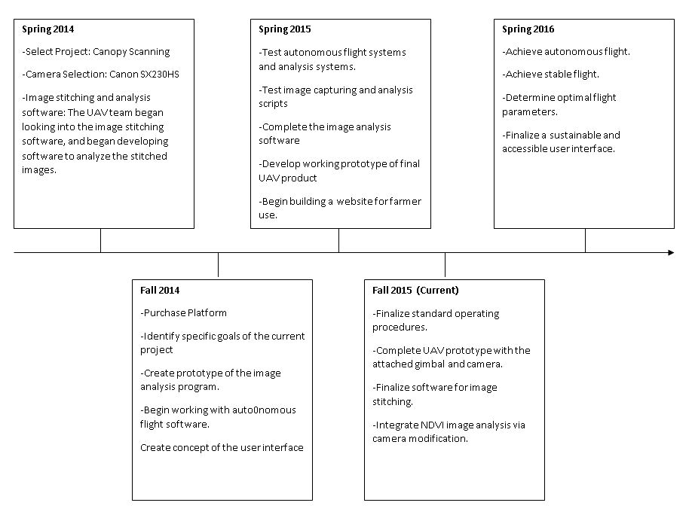

## Current Phase in the Design Process and Location on Overall Project Timeline

**Overall Project Timeline**

The past project timeline of Spring 2014 gave an estimated end date of Spring 2015, by which time a physical prototype would be functional and ready to present to the community partner. However, complications encountered by teams of previous semesters pushed the end date to the end of this fall 2015 semester. To meet the deadline, the UAV team worked throughout the fall 2015 semester to reach the goal of an autonomous flight-and-image-processing platform by November 17, 2015.

Presently the project has reached the “detailed design phase” for the platform portion and the “conceptual design phase” for the image processing portion. These phases and the work accomplished during this semester are outlined in detail below.  With respect to the project timeline given by last semester’s UAV team, both portions should have reached the “delivery phase” by this time.

### Goals for the Semester

**Platform**

The main focus of the UAV’s platform team of the fall 2015 semester is to finish the modifications to the unmanned aerial vehicle (“drone”) that will allow in-field testing for future semesters.  The platform team also plans to modify the vehicle’s on-board camera in order to take infrared (IR) images and to optimize the image-taking process.  The platform team’s goals for the 2015 semester are listed below:

1. Modify camera to take IR images.
2. Mount camera to platform in such a way that the camera lens is normal to the earth’s surface.
3. Prepare platform for autonomous flight.
4. Optimize flight path and/or camera setting to expand on the reliability of the image-taking platform.

Infrared photography can be used to detect diseases, infestation, and other stress factors in plants before signs are easily detectable to the human eye.  This is because plants normally reflect near-infrared light.  When plants are under stress, they reflect much less infrared light and appear darker on a picture taken in the infrared spectrum.    The UAV team’s platform team hopes to use infrared photography to enhance the capabilities of the image-taking platform.  A cheap and simple modification of the camera is necessary in order to render it usable in the infrared spectrum. This involves physically removing a filter inside the camera.

Second, the camera must be mounted to the platform.  The platform team is designing the mount to satisfy two parameters: security and mobility.  Although the camera must be mounted securely in place, it must also be able to move relative to the drone in case of tilt.  The platform team determined that the cheapest and most effective solution would be the utilization of a ball-and-joint system.  The ball-and-joint acts as a makeshift “gimbal” (a pivoted support that allows the rotation of an object about a single axis) that will allow for the camera to always face toward the direction of its pull normal to the earth’s surface, regardless of the angle of the vehicle.  Although a ball-and-joint system can be purchased, custom-designed parts are necessary to mount the ball-joint system to the quadcopter, and to mount the camera to the ball-joint system.  These parts will be designed, modeled, and constructed by members of the platform team this semester.

Third, the platform team must become familiar with the drone’s built-in “Mission Planner” software, which automates the flight path of the drone and helps regulate vital parameters of the drone, such as battery life and range.  If this step is completed, the platform team will be able to analyze the flight parameters and make suggestions for optimization.  (For example, it could be the case that the camera and mount weigh too much, draining the battery and reducing the maximum possible flight time by as much as half.)

**Imaging**

Because the original timeframe set by previous team’s promises completion by the end of the fall 2015 semester, the imaging team’s focus is to create a finished software package that will be presented to the community partner. Building on the work completed by previous teams, the imaging team has identified the goals necessary to complete the project by the end of the semester, outlined below:

1. Automate the post-flight image analysis process
2. Optimize and expand on the capabilities of the crop analysis code
3. Address image stitching errors within our current image stitching implementation
4. Creates simple output interface for displaying the final results and relevant information to

First, the imaging process must be automated to reduce the amount of work performed by the end user. With a higher level of automation the likelihood for variation or error from user input decreases, resulting in increased overall customer satisfaction.   This step is crucial to the project’s success, as the target market demographic is unlikely to invest time into navigating complicated algorithms to obtain the final result.  A product that is reliable and easy to use will ensure a high probability of continued use.  The goal of the imaging team is to write a script that

Will make the process easy to use and reliable.

The script in question will run three separate programs. The stitching program will first create a panorama from the images obtained from the drone.  Next, the analysis program which will extract data from the image. Lastly, the output program will produce an output that the target demographic can easily understand.

The second goal of the imaging team is to expand on the image analysis code written by the previous semesters.  Though the existing code does produce meaningful data, the program is not fully complete. The algorithms must still be optimized for the specific color ratios indicative of Pierce’s disease and other similar crop diseases. This step requires research into specific agricultural concepts such as Normalized Difference Vegetation Index (NDVI) and Leaf Area Index (LAI), to name a few, as well as collecting raw data from vineyards and orchards to test the image analysis code.

The imaging team’s third goal is to improve the quality of the final stitched panorama. The software that past teams have decided to use is Microsoft Image Composite Editor, or ICE for short. This image stitching software is able to produce panoramas from the pictures taken by the aerial device, though the final stitched image contains minor, albeit visible, stitching errors.  The imaging team plans to increase the accuracy of the final panorama by addressing these stitching issues in the following fashion: most stitching algorithms assume rotational - rather than translational - motion about the camera axis.  Since the aerial device discussed moves in a strict translational fashion, a panoramic picture stitched under the assumption of rotational motion will necessarily create errors. For example, one stitched image shows a slight curve in a road that is actually straight in the original image. These stitching errors are often caused by a lack in overlap between images, distortion in the original images, lack of distinguishable features, and parallax errors. Problems with stitching distortion are usually reduced with plenty of overlap in the original images, so collaborating with the platform team to include plenty of overlap between images should fix these issues.  By manipulating the settings of the Microsoft ICE software to better suit the needs of aerial photography panoramas and by collaborating with the platform team to obtain images with more overlap, the team hopes to improve the quality of the final stitched photograph.

The imaging team’s last - and perhaps most important - of the fall 2015 semester’s goals is to create a simple and user-friendly interface to display the data obtained from the analysis program.  The interface should be easy enough to navigate so that the target market demographic - farm workers with minimal computer expertise - can comprehend the data derived from the image analysis code.  It should also be detailed enough so that the consumer is able to take meaningful action based on the information obtained from the program.  If the analysis process is repeated on a regular schedule, the interface should allow a way to visualize changes to crops over time, providing insight to the consumer about changes to their crops, whether good or bad, possibly even offering suggestions to improve the season’s yield.

### Semester Timeline

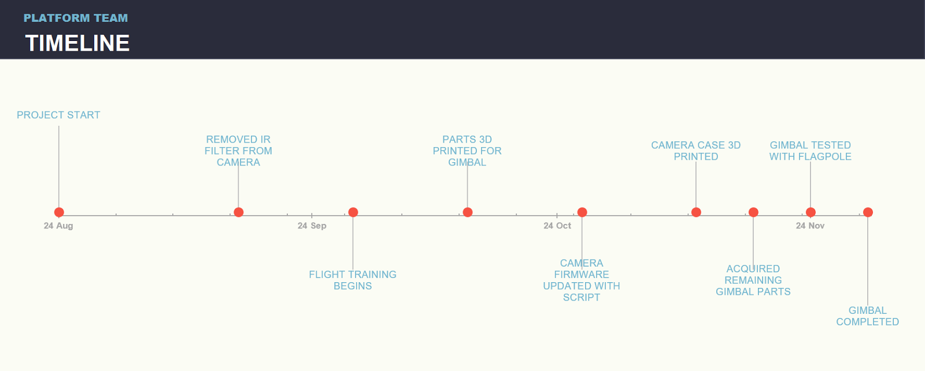 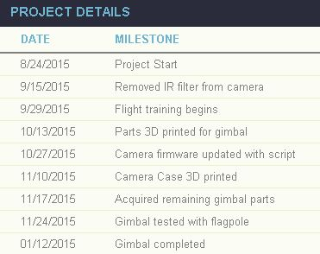

### Semester Budget

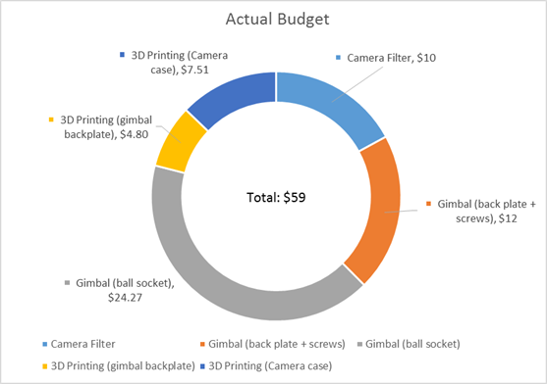

|  |  |
| --- | --- |
| FALL 2015 Actual Budget |  |
| **Item** | **Cost** |
| Camera Filter | $10 |
| Gimbal (back plate + screws) | $12 |
| Gimbal (ball socket) | $24.27 |
| 3D Printing (gimbal back plate) | $4.80 |
| 3D Printing (Camera case) | $7.51 |
| **Total** | **$59** |

Our actual budget was considerably lower than our original estimated budget. However this is due to our decision to stay with free software and our decision to hold off on buying a new camera. So as a note to next semester, the original estimated budget should be considered.

### Summary of Semester Progress

**Platform**

The camera’s gimbal has been completed and is ready for testing. It allows the camera to be attached via the 3D printed case to the quadcopter, and face towards the ground. The camera has been set up in such a way as to automatically take pictures at a time interval given by a changeable script.

**Imaging**

The image stitching portion of the program, which uses Microsoft ICE, has been improved on. Major progress has been made on the analyzation portion of the program. The algorithm of this portion is now optimized to use NDVI over RGB. The algorithm is able to distinguish vegetation over non vegetation and distinguish the magnitude “greenness” of vegetation. However the values analyzing color do need to be fine-tuned to distinguish the discoloration of Pierce’s Disease, which are in hues of red, yellow, or orange. An interface has also been created to easily run the program through each stage of stitching and analyzation.

## Transition Report

### Projected Goals

Based on the progress the team has made this semester in completing the analysis code and attaching the camera to the drone, next semester’s UAV team should focus on obtaining and synthesizing data. The team should aim to meet with their community partner early in the semester, Larry Burrow, and schedule dates to visit potential vineyards for actual infrared imaging (IR) testing. The team should focus on acquiring enough data to establish the validity or the potential benefit our project can serve the community. The data acquired will also help determine if any modifications should be made to the drone itself or any refinement should be made to the team’s analysis code. As an end goal the team should focus on completing phase five of the project (Delivery) by the end of their semester to allow the following semester to begin working on the last phase of the project, phase six, Service and Maintenance. Setting said goal to be achieved at the end of the semester will allow the possibility of the overall project to be completed by fall 2016.

### Projected Timeline



### Task Description

To achieve the goals set out for next semester, the team should meet with their community partner, Larry Burrow, early in the semester in regards to potential testing fields for the acquisition of data. The team should take IR images of the vineyards every two to three weeks to allow enough time to process the pictures and document the information obtained from the images. Based on the first two sets of data collected the team should determine whether any refinement or tweaks should be made to the code or whether any modifications should be made to the drone. When flying the drone, the team should document any important information regarding flight conditions and any important details about the flight test. The team should also consider refining their user interface program to accomplish the proposed goal of the project being completely autonomous with little or no user interaction. The last relevant task for the team to consider is making sure that the imaging software is compatible with any system mac or Microsoft.

By week two or week three of the semester the team should have met with Larry Burrow to allow enough time to get in contact with potential 3rd party partners that will grant the team access and permission to take aerial photographs of their vineyards. The platform teams is most suitable to accomplish this task, particularly any members who are qualified or knowledgeable in flying the IRIS drone. The IPO should also be aware of any legal issues or scenarios that can arise when flying a drone and taking photographs at a 3rd party’s property.

When contact is established with a potential 3rd party and permission is granted,  the platform team should take IR images of the vineyards using the team’s camera and drone every two or three weeks. Such time will allow the imaging team to process all the photos collected through their imaging software and allow them to document any information derived from the analyzed photos. The imaging team should consider documenting the quality of the photos taken when drone is in motion, the accuracy of the stitched panorama created by their software, the precision of the software’s ability to determine the ‘greenness’ or health of the vineyards using NDVI and the capability of the farmer to be able to determine the location of potential problems based on output image created by the team’s software.

Based on the acquired information from two different sets of data obtained after running the software, the imaging team should determine the origin of the mistakes and whether poor data is a result of malfunctions with the imaging team’s software or flaws in the platform team’s design of the drone. The platform team should note that it is crucial to the success of the project to gather enough information as well during flight testing and the acquisition of aerial photographs. Any information regarding flight conditions is important to document as it can affect the type of images collected or can affect flight time. The platform team should also document the amount of time the drone was in the air with the camera attached and the amount of time the drone was in the air without the camera; the altitude of the drone as it hovers over the vineyards to take photographs; the amount of photos taken as the drone was in the air; the amount of time it took the drone to complete its predetermined course set using Mission Planner and any other relevant information that will help determine the efficacy of the team’s project.

Lastly, the imaging team should consider refining their user interface program in the hopes of accomplishing the possibility of the team’s project to be completely autonomous with little or no user interaction. To do so the imaging team can consider ways into integrate Mission Planner into their imaging software as both features are independent of each other. The imaging team should also work on verifying that their imaging software is compatible with any system used by the user.

Working on the prescribed task mentioned above will help ensure the possibility of the overall UAV project to be completed by fall 2016.

### Semester Budget

|  |  |
| --- | --- |
| Spring 2016 Proposed Budget |  |
| **Item** | **Cost** |
| Additional Batteries | $100 |
| Additional Camera | $200 |
| Additional Costs and Fees | $100 |
|  |  |
| **Total** | **$400** |

### Most of the team’s funds next semester are expected to be predominantly associated with materials and travel. It is in the team’s best interest to buy extra battery packs for their IRIS drone to allow the task of taking aerial photographs to be more feasible. With the camera attached to the drone the flight time is expected to decrease and the life of the drone’s battery to be shorten. To combat this issue the extra battery packs will allow the team to accomplish their task of taking photographs without having to waste time in recharging the dead battery. It is also in the team’s best interest to consider buying a different camera that weighs less than their current camera. Doing so can avoid issues of the camera’s battery life from depleting and having to waste time in waiting for the camera to recharge; a different camera with less weight can help negate the issue of the drone’s shorter flight expectancy and help prevent the drone’s battery from depleting too quickly because of the weight it is carrying. It is always more convenient to have an extra camera at hand in case of any malfunctions or possible damage that can result in flight testing. In terms of travel expenses, the team is expected to be traveling every two to three weeks to a 3rd party’s property that can potentially be more than a 15-20 mile drive from campus. Not until the location of the flight testing has been determined, will the travel expenses be properly accounted for as the distance traveled to such location will affect the amount of money associated with each visit.

### Resources Needed

Based on the tasks and goals set forth for the following semester no outside or additional resources are anticipated to be required.

# Past Semester Archive

## Spring 2014

### Spring 2014 Members

Platform Sub-Team

Balbuena, Elizabeth - Team Member 🔶 Deruso, Markell - Team Member 🔶

Gonzalez, Sergio - Deputy Leader 🔶 Kam, Scott - Platform Team Leader

Milano, Dominic - Project Manager 🔶 Navarro, Viridiana - Communication Specialist

Turcios, Karen - Team Member

Imaging Sub-Team

Anderson, Andreas - Team Member 🔶 Cato, Shawn - Team Member

Crossley, Cody - Imaging Team Leader 🔶 Thayer, Thomas - Webmaster

Valdovinos, Samuel - Team Member

### Past Timeline

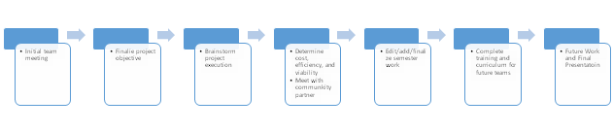 For the spring 2014 semester the project scope was determined, and the overall project was approved by our community partner. We evaluated and identified potential software to use for the project, however such evaluation will have to be ongoing. We determined the general design specifications of the UAV and its payload, and ordered the proper UAV and camera.

For fall 2014, the team will need to assemble the UAV and begin test flights and the proper training required. The camera has been ordered, however the team will need to automate the payload camera, possible via an Arduino microcontroller. Aerial photographs will need to be taken in order to develop, ground proof, and refine the algorithms for image analysis. Lastly, the fall 2014 team will need to create and establish a user-friendly software package that will streamline and automate the process.

## Fall 2014

### Fall 2014 Members

*Platform Sub-Team*

Hernandez, Adrian - Intellectual Property Officer

Manikalak, Phoskrit - Inventory and Finance Officer

O’Rourke, Justin - Platform Team Leader 🔶 Ramos, Cesar - Team Member

Reps, Chris - Deputy Leader

*Imaging Sub-Team*

Berchek, Avery - Team Member 🔶 Espiritu, Francis - Team Member

Harmon, Eric - Team Member 🔶 Kotlarek, Joseph - Team Member

Navarro, Viridiana - Communications Officer 🔶 Sergio, Gonzalez Jesus - Project Manager

Thavornkant, Patrick - Team Member 🔶 Thayer, Thomas - Imaging Team Leader

Vasquez, Walter - Webmaster / Student Advisory Committee Officer

.

### Past Timeline

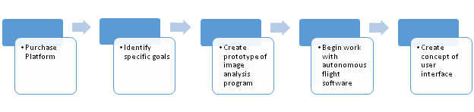 The UAV team this semester has produced multiple prototypes of Image Analysis software, researched and identified a marketable project goal, and purchased a platform for the project.

At the start of the semester, the team had a difficult time recognizing the need being addressed by the team. There was a poor transition report from the previous semester, and the project seemed incompletely defined. The original idea of Canopy Scanning, in which a UAV would take photographs of orchard canopies and determine yield estimates was dropped because it was too vague to serve as the main goal for the team. Team member Viridiana Navarro recognized this problem and came up with the idea of interviewing local farmers to understand their viewpoint on agriculture applications for UAV’s. The interviews were delayed for two weeks as a questionnaire was created by Viridiana in collaboration with MESA lab and the UCCE. The information gathered from the farmer interviews helped the team re-identify the project’s goal to the Detection of Leaf Scorching in grapevines as caused by Pierce’s Disease and many other Diseases and Nutrient Deficiencies. The Farmer Interviews also gave insight on what future developments that local farmers would look for. Detailed information on the farmer interviews including recording and transcripts of the interviews can be found in the Video Interview Folder within the fall 2014 UAV folder on the Box.

After the project goal was thoroughly identified, the imaging team was able to identify a method for identifying leaf scorching in aerial images of crops. They decided to try different methods to detect leaf scorching including Hue, Saturation, and Vibrancy (HSV) and Red, Green, Blue) RGB Threshold alterations. The Imaging team produced four programs, each able to isolate specific characteristics of images. The RGB to Gray Auto Threshold program was able to identify trouble areas in some sample imagery provided by MESA Lab, and gave a percentage of the image identified as a troubled area. The Alpha Analysis software is used to outline the crop fields from images, isolating them from the rest of the image. This was created in order to assist the RGB Threshold program in producing a more accurate analysis by avoiding areas which aren’t

Considered a part of the crop field. Microsoft Image Composite Editor (ICE) is still the image stitching software, however should only be temporarily used since it is known to produce abnormalities in the images it produces.

## Spring 2015

### Spring 2015 Members

*Platform Sub-Team*

Chang, Kaycee - Platform Team Leader 🔶 Del Valle, Michael - Intellectual Property Officer

Diaz, Eduardo - Team Member 🔶 Kirshman, Armand - Inventory Finance Officer

Perez, Manuel - Team Member 🔶 Reps, Chris - Project Manager

Soria, Nikolas - Team Member

*Imaging Sub-Team*

Cheung, Kelvin - Team Member 🔶 De Jesus, Savannah - Communications Officer

Kirk, Kyle - Team Member 🔶 Monroy, Tomas - Student Advisory Committee Officer

Sosa, Eric - Deputy Leader 🔶 Stratton, Austin - Imaging Team Leader

Vargas, Ulises - Webmaster

.

### Spring 2015 Semester Timeline

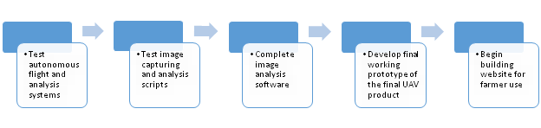

In comparison to the overall timeline the project is approaching its end, nearing the last

Semester or two that it will be active with the same mission. This semester the team has set the groundwork for much of the operational procedures for the next semester such as creating safety manuals and checklists to ensure safe operation of the UAV. Even though not much was accomplished in terms of the software coding the team still made valuable leaps for the imaging component. The team created a control orchard to observe the leaves under strictly controlled conditions so that they can be analyzed and then later compared to actual fields.

Due to the slow progress on the software, the project is estimated to take another two semesters to complete. Though it is possible to complete the project the next semester it is not entirely likely as the task of finalizing the code may take longer than expected if those working on it are not as knowledgeable as the original author. The next semester will focus highly on completion of the software code and the finalization of the operation manuals. Additionally, the next semester will ideally sent people to MESA lab to be trained to fly a UAV and begin taking pictures over farmer’s fields to analyze.

The past project timeline (depicted above) estimated that by the end of the Spring 2015 semester a functioning prototype of the UAV system would be complete and ready to capture and analyze aerial images. Although the set goal wasn’t accomplished due to software

Complications in developing the function of autonomous analysis, the software is still able to analyze the photographs of interest with the aid of a user who is trained to analyze such photos.

However, the necessary steps have been taken to complete safety procedures before, during, and after flight as to standardize safety procedures for future teams that will be working with this project. The decision was made that a website was not to be created since it was not a main component of our ultimate goal and could be left to be done after the project was complete.

The completion of ground test at MESA lab available for future teams to utilize was accomplished this semester. The landscape is comprised of several rows of almond trees to provide a baseline of comparison for larger projects such as a farm. Since the trees can easily be maintained and kept in a controlled environment then results can easily be compared to test data to either calibrate the software or to determine a specific problem. The next semester will need to finalize the software code in order to have a prototype ready, and train new members to be able to use Mission Planner effectively.